Liberty University Engineering Enhancement Proposal

Group 6: C. Eichmeier, I. Estrada, C. Quirke
School of Engineering: Liberty University
ENGR 270-001: Technical Communications
Dr. Charla Bansley
April 28th, 2025

Table of Contents
Abstract 4
Proposal 1: New Technical Elective 5
Introduction 5
Current Situation 5
Graph 1 7
Benefits 8
Specifics 8
Learning Objectives 9
Feasibility 10
Budget 10
Table 1 10
Timeline 11
Criteria for Evaluation 12
Conclusion 13
Proposal #2 14
Introduction 14
Current situation 14
Proposal #3 16
Introduction 16
Current Situation 16
Solution 17
Plan Objectives 17
Timeline 17
Outcomes 18
Feasibility 18
Plan Management 18
Performance Criteria 18
References 19

Abstract

This proposal request outlines three innovative proposals aimed at advancing Liberty University’s mission while addressing key academic and community needs. The first proposal introduces ‘Introduction to Engineered Propulsion’, a technical elective that fills a curriculum gap by offering students hands-on learning and theoretical insight into propulsion systems. This course aligns with Liberty University’s mission to glorify God by preparing students to lead in aerospace, automotive, and energy industries. The second proposal advocates for a ‘History of Engineering’ course that explores the evolution of engineering innovations and the lives of key engineers across history, including biblical examples of engineering as service to God. Designed to inspire creativity and align student thought processes with past innovators, this course offers a unique perspective on engineering progress while meeting technical elective requirements. The third proposal presents the development of a ‘LU Serve App’ enabling Lynchburg residents to post service requests for Liberty University to fulfill. The app streamlines community service efforts, enhances CSER participation, and fosters stronger relationships between Liberty students and the local community. Collectively, these proposals exemplify Liberty’s commitment to academic excellence, innovation, and Christ-centered service, contributing to student growth, institutional impact, and societal benefit.

Proposal 1: New Technical Elective
“Introduction to Engineered Propulsion”

Introduction
Engineered Propulsion is a cornerstone of modern engineering; with new companies in fields such as aerospace, automotive, and energy. From powerful rockets that propel into space to engines that power everyday transport, propulsion technology embodies the intersection of physics, engineering, and innovation.
This proposal seeks approval for the addition of a new course Introduction to Engineered Propulsion, to the Liberty University Department of Engineering. This course is designed to provide students with a comprehensive foundation in the principles, mechanics, and applications of propulsion systems. The course will explore the scientific principles involved including general thermodynamics, fluid dynamics, efficiency, and energy conservation. It will also delve into hands on experience with models and simulations. With a desire to bridge real world applications, this course will foster an environment of interdisciplinary learning and innovation.
The goal of Liberty University and this course is to (1) glorify God. (2) Train students as champions for Christ, this would include the preparation for careers where Christians can be planted in all areas of the workforce. (3) Increase the reputation of Liberty University academics and its students.

Current Situation
While the Department of Engineering at Liberty University offers an array of courses covering subjects like mechanics, thermodynamics, and fluid dynamics, the current curriculum lacks any specialized courses solely focusing on propulsion systems. Propulsion systems are central to a variety of cutting-edge industries including but not limited to: Aerospace, Automotive, Renewable Energy. These fields are making an impact in the world today through advanced satellites and space exploration, efficient vehicular systems, and innovative kinetic energy production.
The absence of a propulsion focused course limits the ability for students to gain expertise in an area that is increasingly important to modern engineering and in turn does not facilitate Christians to be spread fully through the workforce. Competitor institutions such as Purdue (Purdue Registrar, 2015) and Penn State (Penn State Registrar, 2024) have already integrated propulsion system courses into their engineering programs, giving their graduates a competitive edge in the job market. This course would introduce the possibilities for Liberty graduates to be able to work for such contracts and companies as: SpaceX, Hermeus, Boeing, Airbus, Lockheed Martin, Northrop Grumman, Mercedes, Tesla, US AirForce (Pereira, 2024). By introducing Introduction to Engineered Propulsion, Liberty University can not only fill a critical gap in its curriculum but also position itself as a leader in engineering education.
Plan Description
Solution
To address the current issue of the lack of interdisciplinary engineering growth at Liberty University the following proposal for a propulsion specific introductory course must be added. Addition to this course would mean a 3-credit course available as a technical elective. The proposed course will be structured to provide a balance of instruction, practical experiments, and project-based learning. When conducting a survey on Liberty University Engineering undergrad students, 64% expressed interest in this course and said that if it existed, they would add it to their course calendar for the oncoming year.
This survey result emphasizes the desires of Liberty University engineers. Another focus of the survey was how effective this course would be for their degree and the results are as follows in Graph 1.

Graph 1
Effectiveness Survey for New Technical Elective

This survey is overwhelmingly positive and based on the 21 people that completed the survey, this new course would not only work but be highly effective and desired. It is important that the majority of engineering faculty and students agree on this addition.

Benefits
For any proposal it is important to consider its benefits and disbenefits. The benefits are quite simple and can already be seen by the survey in Graph 1, this course is desirable, impactful, and has an excellent vision for the engineering department. For the students this course would be especially beneficial because it gains specialized knowledge in a high demand area of engineering, acquires practical hands-on experience with propulsion technologies, and it develops interdisciplinary skills. For the department this course would enhance the reputation of Liberty University, attract prospective students interested in aerospace and automotive and other related fields, and it would strengthen industry partnerships and collaborations through research initiatives. The course may also contribute to advancements in clean propulsion technologies and equip engineers to design new systems inspired by the work of God, i.e. creationeering.

Specifics
To understand the specifics of the course more closely, this section will describe the specifics of the course including curriculum and structure. This course would fall under the technical elective requirements in the degree completion plan and would target sophomores and juniors in the engineering department. Addition of this course would mean a 3-credit residential undergraduate course titled “Introduction to Engineered Propulsion” and it would guide the steps of those interested in propulsion. The course is 16 weeks in length and will be delivered with lectures, lab sessions, and project-based learning. It would follow a similar but more intensive approach to the course ENGR 202, Introduction to Creationeering.
- Class Schedule: Two 75-minute lectures with one 2-hour laboratory per week.
- Assessment Methods:
  - Exams (25%)
  - Quizzes (15%)
  - Lab Reports (30%)
  - Capstone Project (30%)
- Prerequisites: Completion of Physics I (PHYS 231) and taken concurrently Thermodynamics (ENGR 320).
- Course Materials:
  - Primary Textbook: Fundamentals of Propulsion (Babu, 2022).
  - Software: ANSYS, MATLAB, and possibly other free specialized simulation software.

Learning Objectives
The selection of objectives this course aims to accomplish for its students are as follows:
- Explain and use the fundamental principles of propulsion.
- Work efficiently in groups for real world scenarios and projects.
- Compare and contrast various types of propulsion systems, evaluating their applications and limitations.
- Analyze and describe performance metrics of propulsion technologies, such as thrust, efficiency, and project impact.
- Apply industry-standard tools and software to design and simulate basic propulsion systems.
- Assess the implications of different propulsion technologies.

Feasibility
The implementation of this course is highly feasible because of the faculty expertise, facility readiness, and student demand. The Department of Engineering already has faculty members with expertise in thermodynamics, fluid mechanics, and related fields. Not only so but the resume of Liberty University’s Engineering Department is extensive enough that minimal additional training or recruitment will be required. Existing laboratory spaces in DeMoss hall and Hudgins would be able to facilitate the propulsion experiments without much addition of specialized equipment. The survey already conducted among the current engineering students indicates a strong interest in courses related to aerospace and automotive engineering, suggesting high registration potential.

Budget
To support the launch and delivery of Introduction to Engineered Propulsion, the estimated budget in Table 1 is proposed. The estimated total cost is $23,000 with an initial $5,000 startup cost.

Table 1
Projected Budget for New Technical Elective
Item | Cost | Specification
Faculty Salary | $15000 | For adjunct faculty or additional workload for current faculty.
Software Licenses | $5000 | MATLAB and ANSYS.
Curriculum Development | $5000 | Initial capital.
Laboratory Expenditures | $3000 | Includes raw material for machining and other expenditures for labs. Note: For a section of 30 students.
Note. This budget is for a singular section of this course.

Timeline
Phase 1: Proposal Development and Review
- Early May 2025: Receive input from faculty and department leadership.
- Late May 2025: Submit proposal for review by the Department of Engineering.
- Early June 2025: Schedule department meetings to discuss feedback and revise proposal.
- Late June 2025: Seek approval from the university’s curriculum committee.
Phase 2: Course Design and Preparation
- July 2025: Develop detailed course content including lecture notes, lab exercises, and project guidelines.
- September 2025: Begin procurement of laboratory equipment and software licenses. Organize faculty workshops to train designated instructors on new course material.
- October 2025: Set up laboratory spaces and test propulsion system models. Finalize informational details to promote the course.
- November 2025: Open course registration for the Spring 2026 semester. Host informational sessions for students to introduce the course.
Phase 3: Implementation
- January 2026: Officially launch the course at the beginning of the spring semester.
- February - April 2026: Conduct lectures, labs, and project-based learning activities per the course schedule.
- April 2026: Host a departmental showcase where students present their capstone projects to faculty and students.
- May 2026: Evaluate student performance, collect feedback, and document best practices for future iterations of the course.
Phase 4: Post-Implementation Assessment and Enhancement
- June 2026: Analyze enrollment numbers, student performance, and feedback to assess the course’s success against evaluation criteria.
- July 2026: Identify areas for improvement and revise the course accordingly.
- August 2026: Prepare for a second offering of the revised course in Fall 2026.

Criteria for Evaluation
The success of the course will be measured against the following criteria:
- Student Enrollment: Targeting a minimum enrollment of 20 students in the inaugural semester.
- Performance Outcomes: Ensuring that students are responding well and 100% of students can pass the course.
- Capstone Project Impact: Evaluating the originality and feasibility of student designed propulsion systems.
- Student Placement: Assessing in the long term the effects of taking this course and securing a career in a similar field.

Conclusion
The proposed course, Introduction to Engineered Propulsion, represents a timely and strategic addition to the Liberty University engineering curriculum. By addressing a growing field of engineering, the course will not only enhance the academics of the Department of Engineering but also prepare students to excel in industries of high demand. With its interdisciplinary focus, hands on learning, and team-based work, this course will empower students to become innovative Christ centered leaders in the field of propulsion.
The Department of Engineering is invited to review this proposal and provide feedback to refine and implement this course. Approval of this initiative will solidify Liberty University’s position as cornerstone for engineering excellence and innovation.

Proposal #2

Introduction
The purpose of this proposal is to suggest a history of engineering course to promote insight and inspiration. An engineering degree at Liberty University requires technical electives. This can range from CNC and Programming Logic Chips, heat transfer, and Unmanned Aerial Systems. These technical electives allow engineers to take classes that they’re interested in while giving them the choice to choose. In the Engineering DCP(degree completion plan) a list of classes must be completed without much wiggle room, except for a few.

Current situation
History is a story of who we are as a species, and many people are aware of that. But what about the history of engineering? Some fragments can be discovered in a normal history class or by reading a book on a few historically famous engineers, but it's difficult to see how the innovators thought from one to the other across the ages. No class at Liberty University teaches the History of engineers.
Plan Description
Solution
The solution is to create a class focused on the history of engineers. This class would give three technical elective credits and progress through history, highlighting engineers. As the subject is focused on history, it may also serve as an information elective. This class can help to build innovators and inspire the future.

Benefits
Not only would this serve to fill an elective credit, but this class would aim to show what environments caused innovation and what the people were going through at the time to spark innovation. This class would allow students to align their thought process with these past innovators to carry on their innovative spirit. It is a well-known fact that history is very important. Adding this class would also serve to allow students to have another option to fulfill their technical elective requirement, which has no similar alternative. This class would inspire future innovators. This class can also highlight Biblical engineering to see how engineers served God, like the construction of the Tabernacle. This class would also highlight past innovators and lesser-known knowledge that may be the “missing piece” to innovation, such as lesser-known techniques.

Specific Plan Description
This class would be based on a textbook, there are two examples: A History of Mechanical Engineering (Wells, 2010) and Engineers: A History of Engineering and Structural Design (Zhang & Yang, 2020). This class would be an 8-week course, there would be no prerequisites to this class, and Top Hat will be used as attendance will be mandatory.
The timeline of this class starts this summer when the course is approved then the design of this course would start in spring where what specific content will be taught; for example, what inventors would be picked to focus around not just because of what they did but also the climate they did it. This will take some time as historical experts will need to be consulted. This course plan would finish with the course being listed and enrollment starting in the summer of 2026

Feasibility
A decent number of people would be interested in the history of engineering class.
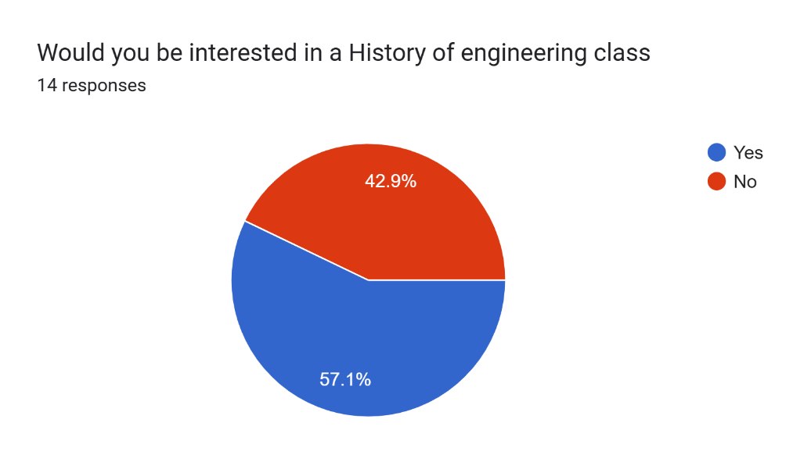
8/14 people said that they would be interested in the history of engineering class. This class would be like other history classes, where there would be an overview of the geopolitical climate at the time, but it would focus on what affected innovators at the time. This idea is quite feasible, neither is it outlandish, and because of that, there is less time, work, and money needed to be spent to implement it.
In conclusion, this proposal is neither risky nor adventurous, but there is still much to gain as the benefits are clear, a historical approach to engineering is informative, inspirational, and without alternative. The number of students who would be interested in this course is skewed when asked if non-engineering majors are interested, but if specifically engineers are asked, then many say yes, they would be interested, and what would a course be if students didn’t want to attend it?

Proposal #3

Introduction
Liberty University has successfully and faithfully represented Jesus Christ and his mission to the world. However, its reputation within the city of Lynchburg itself is questionable at best. An effective way to sway the residents of Lynchburg and thus give glory and proper representation to Jesus is through LU Serve and CSER. Through these programs Liberty seeks to serve its community. However, they could be vastly improved with the development of an app that residents of Lynchburg could use to request certain tasks be completed. This would streamline the process of serving Lynchburg and would effectively ramp up its fruitfulness, which would in turn benefit Liberty’s reputation as a Christ-centered school.

Current Situation
Liberty is the main economic driver in the city as well as its largest employer with over 8000 employees. Its positive impact on the city cannot be overlooked, but it can be diluted. Past controversies, conservative stances, and a minority of misbehaving students have hurt Liberty University’s name, with many believing it to be a racist and hateful college with hypocritical students. This could not be further from the truth. Liberty’s primary strength is found in its student body’s genuine love for and obedience to Jesus Christ and his teaching. One of the best ways this is demonstrated is through its serving programs. However, it could be vastly improved.
The LU Serve and CSER portals currently feel unstructured and lackluster. Notably, they also lack the ability for residents to directly request that certain jobs within the community be completed. This makes completing CSER as a student feel guideless, but it also leaves the community without much evidence of all the good that Liberty does.

Solution
A solution that would satisfy both of these concerns is the creation of an app for both the students and the community. The main page would be a job board that would be filled with posts made by members of the community. Confirmation of the user’s location being in Lynchburg would be required. Then students who are looking to either fulfill CSER requirements or simply serve their community could accept the jobs and subsequently contact the poster. Liberty University’s Lu Serve staff could be involved in the whole process, confirming requests and receiving images that prove completion of each job. The app could be directly linked to Course Registration and update the student’s CSER credits accordingly.
Survey
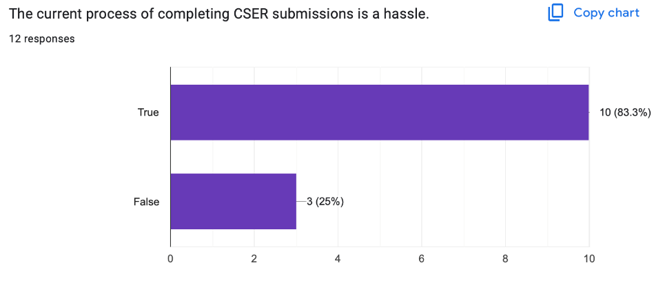
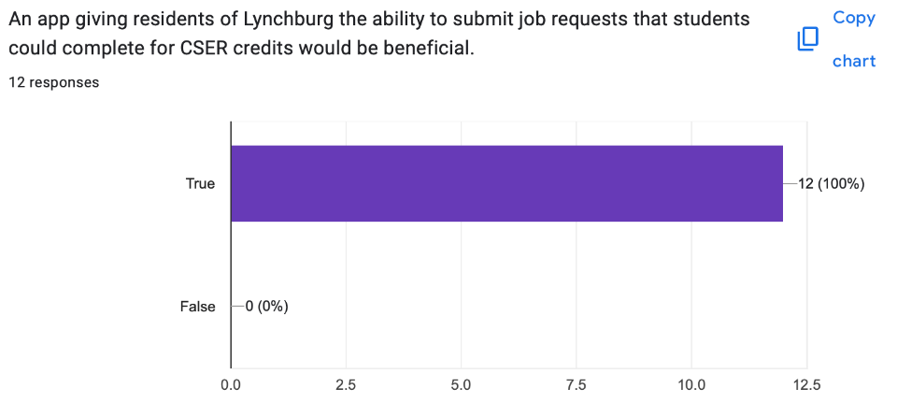
The result

Plan Objectives
Successfully integrating this app into Liberty’s program would be in line with three key values that Liberty claims to exist for: training champions for Christ, being service-minded, and responsibly stewarding resources. The application would make Christ-like servanthood much easier for students to partake in, which would successfully develop them into “Champions for Christ”. The university would be more actively considered “servants” of the community. Finally, effectively making better use of the billions of dollars and the thousands of eager students would be a form of responsibly stewarding their resources.

Timeline
Summer 2025
- LU Serve comes together and agrees upon specific needs regarding the application and its development.
- Advertisements for a group that is focused on creating the application are created and aimed at computer science majors.
- A test is created to ensure the members have at least minor experience in the creation of applications. The club is limited to juniors and seniors.
Fall 2025
- School begins and advertisements are posted throughout campus.
- Potential members take the test.
- Members who are added to the official team begin meeting up and are instructed as to how they are to create the application according to the specifications made by LU Serve leadership.
Spring 2026
- The framework and most of the application has been created and testing/revising begins.
- Upon passing any inspections and being found up to par, the app is released.
- Liberty Information Technology team changes the link from the current LU application submission page to the new application.
- Some advertisements could be made for the Lynchburg area letting the city know about a new way to be served.

Outcomes
- Residents of Lynchburg will receive more help and be served better.
- Liberty Students will have an easier time serving and will be more encouraged to help people.
- Jesus Christ will be magnified by his people serving more.

Feasibility
The two factors that play into whether or not an app could feasibly be integrated into Liberty University’s program are the creation of the app and the ability to get actual users on it. These can both be reasonably addressed.
The biggest roadblock for a company’s ability to create an application usually comes down to funding and skills. Neither of these issues are in Liberty’s way. Billions of dollars flow into Liberty’s funding every few years and a tiny fraction of this money could be used to develop the application. However, it can be addressed with another one of Liberty’s resources as well: its student body. They could hold a competition for Computer Science students to create an app of this kind or simply create a group and invite CS majors to work together on it. Either way this is not a significant hurdle.
The next issue in the way is the process of getting users onto the app. Applications, even ones created by large organizations, can struggle to build a healthy ecosystem of users. In this case, students are already required to complete their CSER credits, so having them complete a submission on this app is as easy as switching the current link on MyLU, the current hub for all Liberty students. Getting the community involved would be more difficult, but not impossible. Liberty could begin to advertise the app, but as it’s beginning to be used for current jobs, it will gain more popularity primarily through word of mouth. Students would tell those that they’ve helped to use the app if they need any more help.

Plan Management
This plan for coordinating an entirely new method for running CSER would require leadership from the Liberty University Information Technology team, LU Serve team, and potentially some computer science department heads. There would likely need to be some sort of approval from Executive Leadership at Liberty University as well, though they wouldn’t need to be part of the creation process.
LU Serve would primarily guide everyone involved in terms of their desires for the app, but the groundwork would be done by the previously mentioned club that would have to be created. Testing could be performed in-house as well.

Performance Criteria
Some of the feedback that determines the success of this plan would come from how smoothly students are able to submit their CSER records. If it became the primary method for completing CSER, it would be clear whether or not the plan was a success. However, the main feedback would come much later as locals begin to use the application to submit requests.
Conclusion
Liberty University’s ability to create Christ-like students is second to none. Initiatives like CSER, LU Serve, and LU Send have effectively blessed not only the surrounding region, but countries throughout the world. This application would bolster the positive effects Liberty is able to have on the local area and would help to bless the students serving their Lord as well.

References
Babu, V. (2022). Fundamentals of Propulsion. Springer International Publishing. https://doi.org/10.1007/978-3-030-79945-8
Penn State Registrar. (2024). Undergraduate Cirriculum Guide. Aero.psu.edu. https://www.aero.psu.edu/assets/docs/penn-state-aerospace-engineering-undergraduate-curriculum-guide.pdf
Purdue Registrar. (2015). Program: Aeronautical and Astronautical Engineering, BSAAE - Purdue University - Modern Campus CatalogTM. Purdue.edu. https://catalog.purdue.edu/preview_program.php?catoid=17&poid=30139&hl=%22aeronautical+engineering%22&returnto=search
Wells, M. (2010). Engineers: A History of Engineering and Structural Design. United Kingdom: Taylor & Francis.
Zhang, C., Yang, J. (2020). A History of Mechanical Engineering. Germany: Springer Nature Singapore.
Emelyn, & Lynchburg Economic Development Authority. (2021, August 24). Lynchburg Colleges & universities are anchors of the economy. Lynchburg Economic Development Authority. https://www.opportunitylynchburg.com/lynchburg-colleges-universities-are-anchors-of-the-economy/
Liberty in name only: Liberty University’s policies undermine freedom of expression. (2019). Retrieved from https://www.thefire.org/news/liberty-name-only-liberty-universitys-policies-undermine-freedom-expression#:~:text=The%20Liberty%20Way%20also%20includes,and%20appropriately%20at%20all%20times.”
Moody, J. (n.d.). Liberty University fined $14 million for clery violations. Retrieved from https://www.insidehighered.com/news/students/safety/2024/03/05/liberty-university-fined-14-million-clery-violations#:~:text=The%20Department%20of%20Education%20hit,forward%2C%20ED%20officials%20announced%20Tuesday.
Pranjal Bora Head of Product Management Pranjal Bora is the Head of Product Management at Digital Authority Partners. After working at Sam’s Club. (2025). Mobile app development for Higher Education: How to build an app students really use. Retrieved from https://www.digitalauthority.me/resources/mobile-app-development-for-higher-education/

